Probability Lab

The Problem: Purdue Property and Casualty Co. (PP&C) sells, among other products, car insurance. Sue Purdue, a long standing customer, has had a claim in each of the last two years. Underwriting would like to know whether or not to cancel her insurance. An important piece of information:

- Underwriting doesn’t want to insure any one who has a greater than 1 in 10 chance of having a claim in any given year.

Underwriting has asked the actuarial department to determine if 2 consecutive years of claims over the life of the policy is consistent with their underwriting standards, assuming a 40 year life for the policy. In other words, what is the chance of having 2 or more consecutive years with significant claims over a 40 year period, if the probability of a significant claim in a given year is 1/10. What about 3 or more?

We will solve this problem two ways: experimentally and analytically. Such experimental solutions are called “Monte Carlo” solutions because of the famous casino at Monte Carlo.

The Monte Carlo Solution: We will use the “Random Number Generation” function in Excel to generate a random sequence of 40, 0’s and 1’s, for which the 0 is 9 times more likely than the 1. We interpret this sequence as representing the accident record of one individual over a 40 year period, where each 1 represents a year in which there was a claim. This sequence represents a “bad record” if it has 2 or more consecutive 1’s anywhere. We will generate 20 such sequences and count the number of “bad records” found, which will give an estimate of the probability someone having a bad record. This process may also be used to estimate the probability of 3 or more consecutive bad years. The final result is shown on p. 4-5 below.

In order to use the random number generator, you may need to apply the add-in. Click on the top left Excel button, then click on “Excel Options” (first screen shot). Select “Add-Ins” from the left side. If “Analysis ToolPak” is located under Active Application Add-ins, you can click cancel. However, if “Analysis ToolPak” is located under Inactive Application Add-ins (as seen in the second screen shot), you will need to make sure the drag down next to Manage: reads “Excel Add-ins” and click “Go…”. Put a check next to “Analysis ToolPak” and click OK (third screen shot). Verify that “Analysis ToolPak” is now under Active Application Add-ins before continuing.

Random number generator is found by selecting Data-Data Analysis-Random Number Generation--OK. A fairly large box should appear. Using the “Distribution” pull-down menu in this box, select Bernoulli. Then fill in the other boxes: the “Number of variables” is 20, since we will do 20 trials, the “Number of random numbers” is 40, since we are looking over a 40 year period, and the “p Value” is .1 since we want 1/10 of the numbers to be 1’s. For the “Random Seed”, use 0. Click onto “Output range” and fill in the box with the location where the first random number is to be entered. Use “C11”. Now select cell “C11,” then “View--Freeze Panes--Freeze Panes.” Before moving on make sure that your lab looks like the fourth screen shot and extends down 40 years.

Next, we need to scan down each column and record the maximum number of consecutive ones in each column. We will get Excel to do this for us. Specifically, create columns numbered 1-20 to the right of the data just produced, beginning in cell X10. Set X11 equal to C11 and put the formula

=C12+C12*X11

into X12. Drag this formula on down to year 40. The range X12:X50 will still be highlighted. Drag this range over to column AQ. You should get the rest of the picture on p. 4-5. This table counts the number of consecutive 1’s. For example in mine the run length entry for the 8th trial in year 34 is 3. This tells us that for this trial, at the end of year 34, our policy holder had had three consecutive “bad” years. Indeed there are 3 consecutive 1’s in column 8 of the Accident Record, ending at year 34. You should think about why this formula works.

For the row marked “max” we used the MAX function of Excel to compute the maximum of the entries in each column. For example,

=MAX(X11:X50)

From the data on p. 5, 7 of our 20 customers (35%) had 2 or more bad years.

The Analytical Solution:

In any given year we can divide our policy holders into 3 groups:

Group A: Those who haven’t yet had 2 consecutive bad years and who didn’t have a significant claim last year.
Group B: Those who haven’t yet had 2 consecutive bad years, but did have a significant claim last year.
Group C: Those who have already had 2 or more consecutive bad years.

Let A(n), B(n), and C(n) denote, respectively, the number of people who at the end of year n belong to Group A, to Group B, and to Group C. The only ways of getting into Group C is either to already be there or to come from Group B. In any given year, we expect that 1/10 of those in B will have an accident. Hence, we expect that

C(n+1)=.1 B(n)+C(n)

An individual in Group B will not stay in B; either he/she will have an accident and move into C or he/she will not have an accident and will move into A. Hence, the only members of B are new ones coming from A. Since, on the average, 1/10 of those in A will have accidents, we expect that

B(n+1)=.1 A(n)

Finally, an individual can get into Group A either by virtue of already being in A, and not having an accident, or by being in B, and not having an accident. Since the fraction not having accidents is 9/10, we expect that

A(n+1)=.9 A(n)+.9 B(n)

Using these formulas, we can use Excel to calculate, year by year, the fraction of policy holders in each group. If we initially have 1 policy holder then in year 0, nobody has had an accident so

A(0)=1, B(0)=0, C(0)=0

We continue the spread sheet as shown on page 5.

Remark: In this lab, we are modeling our accident record as a Markov Process. In our case, this means that we are assuming that the probability of an individual having an accident in any given year is independent of the history of the individual and, thus, depends only on the group. In our analytic solution, we set up a Markov Chain to solve our problem.

The Assignment (Part 1)

Your first assignment is to recreate Sheet 1 of my workbook as described above. Name this sheet “Monte Carlo.” (Double click on the tab to change the name of the sheet.) Note the number of trials with 2 or more consecutive 1’s and the number of trials with 3 or more consecutive 1’s. You will not get the same answers. In a blank cell, enter, as a decimal, the fraction of trials that contain 2 or more consecutive 1’s and the fraction of trials containing 3 or more consecutive 1’s. Label these cells appropriately.

The Assignment (Part 2)

Next, on Sheet 2 of your work book, recreate Sheet 2 of my workbook, as described under the heading “Analytic Solution.” Call this sheet “2 or more.” The entry in D45 is the probability of 2 or more consecutive accidents in a 40 year period. Compute the difference between this value and the experimental value found on Sheet 1. Enter it in a blank cell labeled “Experimental Error.”

The Assignment (Part 3)

On Sheet 3, create a spread sheet that computes the probability of 3 or more consecutive years with claims in the 40 year period. Call this sheet “3 or more.” For this you will divide your policy holders into 4 groups, A, B, C, and D. D will consist of those who have already had at least 3 consecutive bad years. The other groups are defined by:

A: those who did not have a claim last year and do not belong to D.
B: those had a claim last year, but not the year before, and are not yet in D
C: those who had claims in each of the past two years, and are not yet in D

Let A(n), B(n), C(n), and D(n) be the number of people in each group at the end of year n. You will need to write formulas for A(n+1), B(n+1), C(n+1), and D(n+1) in terms of A(n), B(n), C(n), and D(n) similar to those in our analytic solution. This will tell you how to construct the spread sheet.

Finally, compare the actual probability of 3 or more claims with the value found from the Monte Carlo solution.

What to turn in: You should e-mail the TA a single workbook with 3 sheets. The first sheet will be the Monte Carlo solution together with the observed fractions of policy holders with 2 or more and 3 or more accidents. Sheet 2 will be the analytic solution for 2 or more consecutive bad years, together with the “Experimental Error” and Sheet 3 will be the analytic solution for 3 or more consecutive bad years, together with the “Experimental Error.”

Upload the completed project to Blackboard prior to the deadline indicated in Blackboard following the instructions in the “Instructions for submitting labs” found on the course web page.
Picture 1
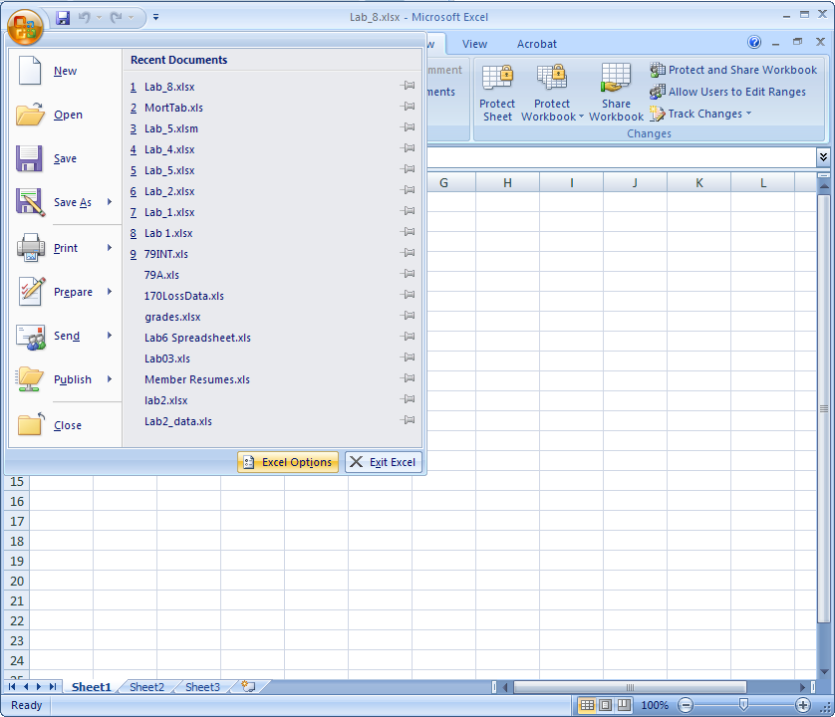
Picture 2
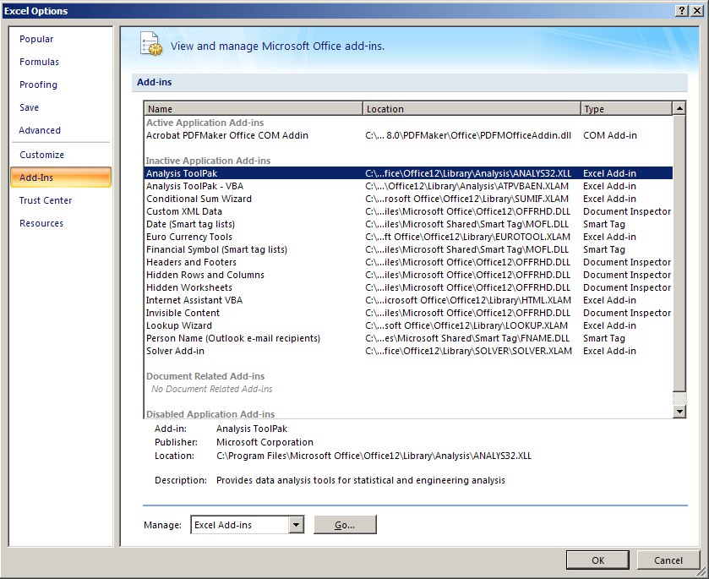

Picture 3
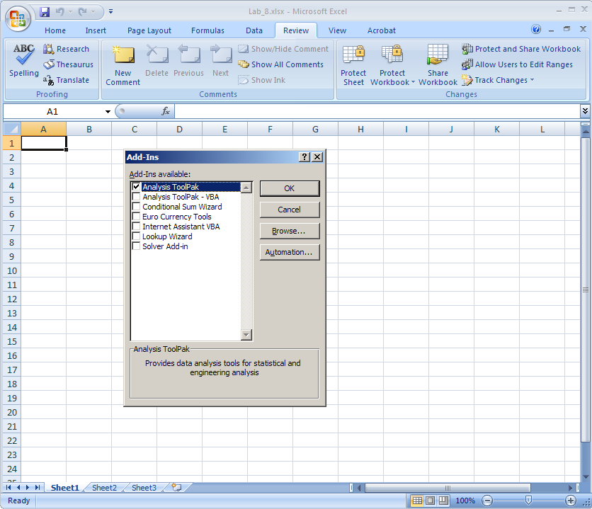

Picture 4
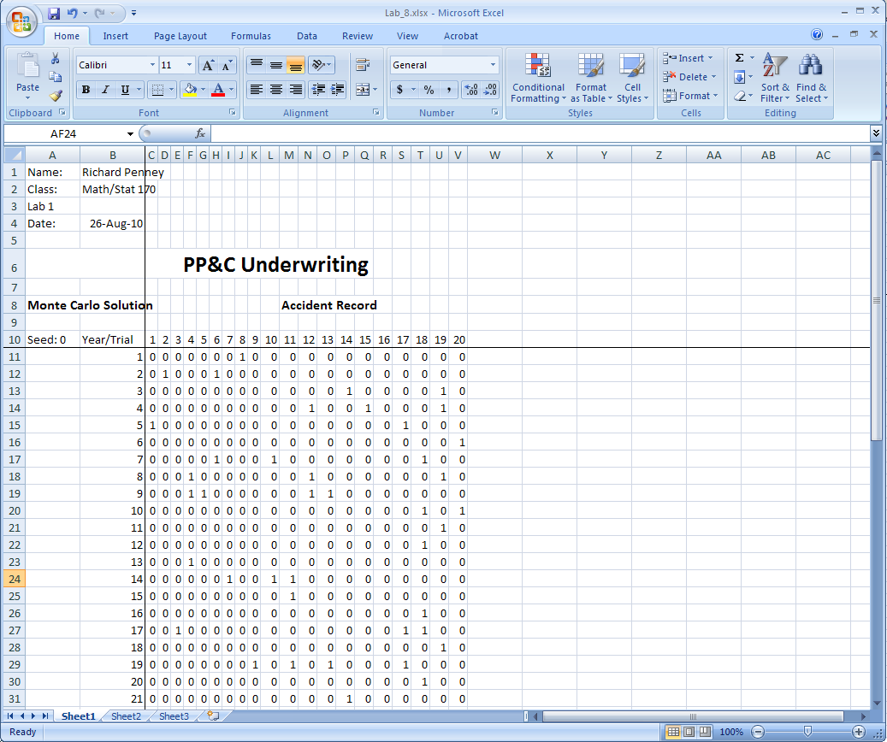

Picture 5
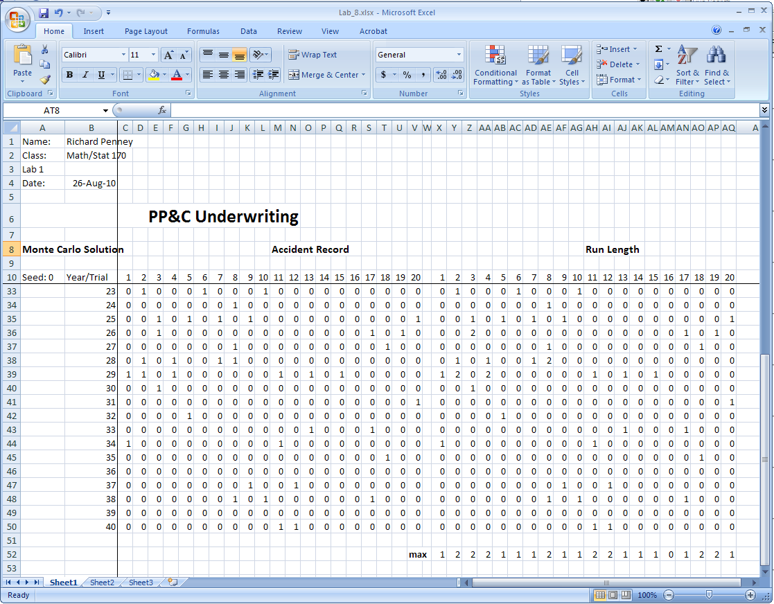

Picture 6
